

**CMPE 277**

**DEPARTMENT OF COMPUTER ENGINEERING**

**Individual Application**

**Guess the Celebrity**

**Submitted to**

**Prof. Chandrasekar Vuppalapati**

**Submitted by**

**Harsha Yadav Kommanaboyina**

**010040654**

**Introduction:**

Guess the celebrity is the application which randomly shows a celebrity Image with four options. The user has to guess the celebrity from the given four options. If the user selects correct option then the application shows toast message as correct otherwise it shows as wrong along with the correct celebrity name. I have taken the celebrity images from <http://www.posh24.com/celebrities> using AsyncTask download service of android. This application requires internet connection to work.

**Application Architecture:**

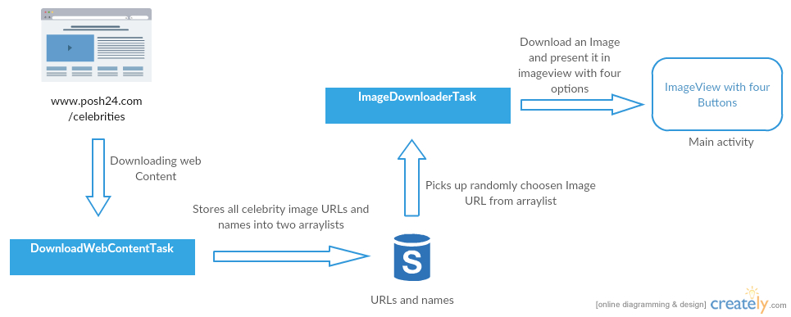

Fig: Architecture of the application

I have used the concept of AsyncTask which is one of the important concepts of android. AsyncTask allows you to perform asynchronous work on your user interface. It performs the blocking operations in a worker thread and then publishes the results on the UI thread, without requiring you to handle threads and/or handlers yourself. To use it, you must extend subclass AsyncTask and implement the doInBackground() callback method, which runs in a pool of background threads. To update your UI, you should implement onPostExecute(), which delivers the result from doInBackground() and runs in the UI thread, so you can safely update your UI. You can then run the task by calling execute() from the UI thread.

Android SDK has recognized this as a pattern and abstracted the handler and thread details into a utility class called AsyncTask. You can use AsyncTask to run tasks that take longer than five seconds in the context of UI.

The AsyncTask (through generics) needs the following three parameterized types (Params, Progress, and Result) when you extend it. Let's explain these types briefly:

1. **Params (The type of parameters to the execute() method):**

When extending AsyncTask, you will need to indicate the type of parameters that you will pass to the execute() method. If you say your Params type is String, then the execute() method will expect any number of strings separated by commas in its invocation such as execute(s1,s2,s3) or execute(s1,s2,s3,s4,s5).

1. **Progress (Parameter types to the progress callback method):**

This type indicates the array of values passed back to the caller while reporting progress through the callback onProgressUpdate(Progress... progressValuesArray). The ability to pass an array of progress values allows situations where multiple aspects of a task can be monitored and reported on. For example, this feature could be used if an AsyncTask is working on multiple subtasks.

1. **Result (Type used to report the result through onPostExecute() method):**

This type indicates the type of the return value that is sent back as the final result from the execution through the callback onPostExecute(Result finalResult).

**Implementation:**

I have used two classes which extends AsyncTask. The first class DownloadWebContentTask is used for downloading the web content from the given URL <http://www.posh24.com/celebrities> and the second class ImageDownloaderTask is used for downloading an image which is randomly selected from the image URLs which are available from the first class. The application randomly picks an image with four possible options and the user has to choose one option. After answering the question the application shows another question.

**Screen Shots:**

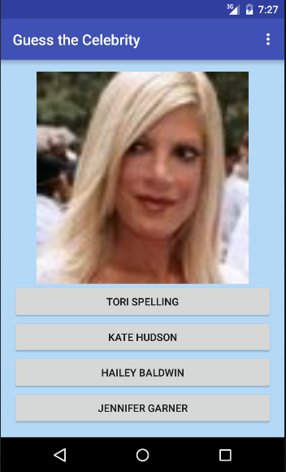

Home Page



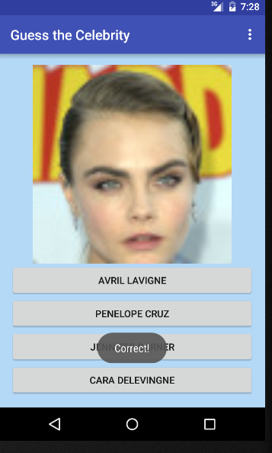

Screen with toast message as correct

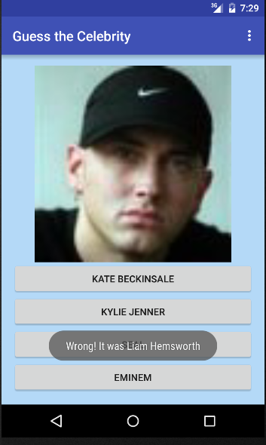

Screen with toast message as wrong